CURRICULUM VITAE

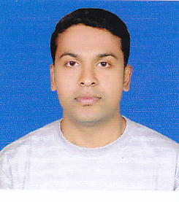

mohammed shafeeq m

mangalassery(h)

nellaya (po)

PALAKKAD (Dist)
PIN: 679335
KERALA

Ph: 9847628095, 8606171494

E-mail id: shafeeqman@gmail.com

CAREER OBJECTIVE

To work with an organization that encourages continuous learning so as to achieve professional and personal growth along with the organization goals and contribute better each time.

educational QUALIFICATION

- Bachelors Degree in Computer Application(Aggregate 65%)
Under BANGALAORE UNIVERSITY, Bangalore during 2007-2010
- PLUS TWO (Aggregate 66%)
Under BOARD OF HIGHER SECONDARY EDUCATION from G.H.S.S, Cherpulassery during 2005-2007.
- AISSE (Aggregate 71%)
Under CBSE from M.T.I Central School, Pottachira during 2004-2005.

ACADEMIC PROJECTS

Main Project
Project Title : ADHOC NETWORK
Organization : Systems Domain,Bangalore
Duration : April-May, (2010)
Description : This includes controlling the network System where transfer of data takes place between two networks in encrypted mode. I used programming language JAVA and softwares jdk 1.5,jmf 1.2.1.e .

TECHNICAL SKILLS

- Programming Languages : C,C++,Java,VB6.0,Unix
- Relational Database : Oracle 9i
- Operating system : Windows,Unix

STRENGTH
- Good communicative, decision making & analytical skills.
- Effectively in group as well as individual.
- Eagerness to learn and explore

WORK EXPERIENCE
Fresher

PERSONAL DETAILS

- DOB : 05-06-1987
- Gender : Male
- Nationality : Indian
- Fathers Name : Mohammed Mangalassery
- Passport Number : J8241907
- Licence Number : 51/260/2009
- Languages Known : English,Hindi,Kannada,Malayalam

DECLARATION
I do here by declare all the above statements are true to best of my knowledge.

Place : Cherpulassery Yours Faithfully Date : 25-06-2011 Mohammed Shafeeq

